CACFP Compensation Protocol

TABLE OF CONTENTS

INTRODUCTION 4
BACKGROUND 6
SOLUTION 7
TDA CACFP Salary & Wage Income Protocol
CONCLUSION 11
APPENDIX 12
Excerpts from the NAICS
Occupational Employment and Wage Statistics (OEWS) Overview
Categorical Roles
Excerpt from CFR 200
Excerpt from FNS 796-2 Rev. 4
Labor Costs Example
Additional Question and Response
Excerpt from BLS - Metropolitan Area Concepts and Standards
CACFP Salary Determination Detail
Employer Cost for Employee Compensation
Program Statistics
CACFP Salary and Wage Tables
ADDITIONAL RESOURCES 23

INTRODUCTION

Purpose: To establish a method for determining reasonable and allowable compensation for base salary and wage income as directed by 2 CFR 200.430(b) and FNS 796-2 Rev. 4.
Background: Consecutive USDA Management Evaluations have cited the need to develop written guidelines and procedures which determine whether costs are necessary, reasonable, and allowable for the administration of the CACFP Program. Federal Guidance requires that State Agencies determine that all costs associated with the administration of the CACFP are necessary, reasonable, and allowable.
Analysis has shown that the base salary income of some upper-level staff operating CACFP programs are not reasonable when compared to rates paid for similar work in like organizations within their locale.
Requirements: (As indicated in FNS 796-2 Rev. 4, 2 CFR 200 & other applicable USDA Guidance)
- All institutions participating in child nutrition programs must operate a nonprofit food service principally for the benefit of enrolled participants.
- Institutions participating in child nutrition programs must have adequate non-child nutrition program funds to pay institution obligations during temporary interruptions in CACFP payments and non-food service obligations. That is, institutions must have other sources of revenue and cannot rely solely on child nutrition program funds.
- Compensation or salary and wage income charged to the nonprofit food service account can only be for work rendered to the nonprofit food service program.
- Compensation or salary or wage income charged to the nonprofit food service account must be based on the job functions and not the job title of the individual.
- Institutions participating must ensure compensation or salary and wage income is reasonable when compared to similar organizations within the same geographic area.
- Child Nutrition Institutions fall within the NAICS “Social Assistance” service industry which is most closely aligned with child nutrition program functions.
Solution: Development of a salary protocol which provides an adjusted, consistent, and equitable means of evaluating proposed salary and wage income. The protocol was created by:
- Analyzing the North American Industry Classification System (NAICS) to determine the industry most closely related with CACFP.
- Analyzing Bureau of Labor Statistics (BLS) to determine the fields of employment most closely related with CACFP program functions.
- Gathering BLS industry median wages from the Texas Workforce Commission (TWC) for Texas metropolitan statistical areas (MSAs).
- Determining Min/Max salary income based on BLS percentile wages.
- Applying 15% reimbursement rate for centers and administrative reimbursements for DCH to determine if salaries and wages exceed what is allowable as it concerns CACFP.
Summary: Employing this salary and wage income protocol provides a standard, consistent, and equitable means for evaluating the program incomes drawn from child nutrition program funds. The parameters, assumptions and calculations in the protocol are based on data that is considered authoritative and fulfills the requirements set by 2 CFR 200.430(b) and FNS 796-2 Rev. 4.

Definitions

Allocable Cost | A cost that can be assigned or charged to one or more activities or items (cost objects) on the basis of benefits received or other such equitable or logical association, although a direct (causal) relationship may not be established. Also referred to as allocability.
Allowable Cost | Any reasonable cost that may be recovered under the contract to which it is allocable.
BLS | Bureau of Labor Statistics
CFR | Code of Federal Regulations
Contracting Entity (CE) | A state, local government, Indian tribe, institution of higher education (IHE), or nonprofit organization that carries out a Federal award as a recipient or sub-recipient.
Field of Employment | An occupation or profession, especially one requiring special training, followed as one's lifework. This is an indication of the type of work that is being performed, not the title of the individual or industry in which it is performed.
FNS | Food Nutrition Service
Industry | Any general business activity or commercial enterprise that can be isolated from others.
NAICS | The North American Industry Classification System
Nonprofit Food Service | Includes all food service operations conducted by the institution principally for the benefit of enrolled participants, from which all of the Program reimbursement funds are used solely for the operation or improvement of that food service. Food service account activity must be monitored to determine nonprofit food service status for institutions.
OEWS | Occupational Employment and Wage Statistics
Reasonable Cost | That, in its amount and nature, is consistent with what a reasonable person would incur in the conduct of the same business in the same or similar circumstances.
SOC | Standard Occupational Classification
Salary & Wage Income | Monetary amounts received (straight-time, gross pay, not including benefits) on a regular basis for work on program activities.
TWC | Texas Workforce Commission

BACKGROUND

In TDA’s efforts to be good stewards of the financial and property resources entrusted to us for the administration of the federal food and nutrition programs, it has become apparent that we need to clarify the expectation for program fund allocation as it relates to salaries and wages. Key to ensuring that all of Texas’ children have access to safe, nutritious, and balanced meals, all program operators must be responsible for correctly allocating program expenses. Allowability, which pertains to whether the costs/expenses are reasonable and allocable, is therefore of the utmost importance.

This document covers cost allocation as it relates to salary and wage income charged to the CACFP program. The intent of this document is to ensure that program funds used for salaries and wages are being used for the purposes for which they were intended. This document and the related tool do not include employee benefit costs. Please see Employer Cost for Employee Compensation in the appendix for more information.

SOLUTION

TDA Compensation Protocol

To ensure CACFP funds used for salaries and wages are necessary and reasonable as stipulated by federal guidelines, TDA utilizes the “Social Assistance” industry type as set by The North American Industry Classification System (NAICS). CACFP is a Federal grant program that is considered a nonprofit food service whose sole purpose is the benefit of enrolled participants who rely on its service (see FNS796-2 rev. 4 for clarification). As such, the industry type most closely aligned with the CACFP program purpose is NAICS subsector 624 – Social Assistance (see Appendix Excerpt from NAICS for more information).

Within the NAICS Social Assistance industry subsector, there are BLS Standard Occupational Classification (SOC) and Occupation Codes (OCC) job categories. These job categories have distinct BLS determined salary and wage ranges (See Appendix Categorical roles). The salary and wage income ranges are for CACFP job functions only and should not be confused with the organizational title of the person providing the service, (see the example from the FNS 796-2 on Labor Cost provided in the appendix).

The salary and wage income by job function is based on the Texas metropolitan statistical area (MSA) of Contracting Entities’ office (Table 1). To account for salary and wage differences across the state, TDA uses three MSAs (Dallas-Fort Worth-Arlington MSA, Houston-The Woodlands-Sugar Land MSA, and San Antonio-New Braunfels MSA) with the remainder of the state based on the overall Texas salary and wage data (see Table 2). For a brief description of MSAs please see Excerpt from BLS - Metropolitan Area Concepts and Standards in the appendix.

Note:
It is up to the Contracting Entity to determine the distribution of employee salary and wage income within these parameters. Further, Center and Center sponsor salaries must also be vigilant that they remain within certain mandated limits (i.e., < 15% administrative cost) to ensure allowability.

Requests for increases in compensation must be reasonable, allocable, and necessary. TDA utilizes the U. S. Bureau of Labor Occupational Employment and Wage Statistics (OEWS) data to determine its standard of reasonable. The data supports base salary increases of 4.76%. TDA will consider the following salary increases using CACFP federal funding: 5% for routine annual or merit-based increases and 10% for promotional increases. Job description reviews may occur with promotional increases to ensure that the proposed change aligns with additional duties. Promotional and annual, merit-based increase percentages may not be combined to exceed the thresholds provided by category. Further, promotional increases and raises may not be considered within the same year. Agencies may proceed with increases beyond the TDA allowable ranges but may not use CACFP funds to do so. Any such instances must use non-CACFP funds to cover the increases.

Benefits paid from program funds must not exceed 29.3% of the individual’s salary or wage income. Exceptions will be considered on a case-by-case basis.

For institutions and sponsors administering multiple sponsorship types (DCH, Affiliated/Unaffiliated Sponsor, Independent Center, At-Risk After School Program) and Programs (CACFP/SFSP), the Wage Guidelines must be applied based on sound cost allocation principles. For example:
- If the same monitor is utilized to monitor Daycare Homes and Daycare Centers, that individual should only have one salary or wage that is allocated, based on the percentage of time spent on each sponsorship type.
Or
- If an individual’s role is split between functions (i.e., Program Manager & Compliance Monitor) their total salaries or wages must be based on the percentage of time spent in each role.

This protocol was effective for all new Contracting Entities (CEs) as of October 1, 2017. For those (CEs) who had personnel with salaries currently exceeding this guideline, they had one year to bring their salary or wage income and related benefits into compliance.

(Bureau of Labor Statistics: Occupational Employment and Wage Statistics, Tables, 2023)
(Bureau of Labor Statistics: Wage/benefits compensation split for private industry workers)

TABLE 1 – CACFP Salary & Wage Income Tables

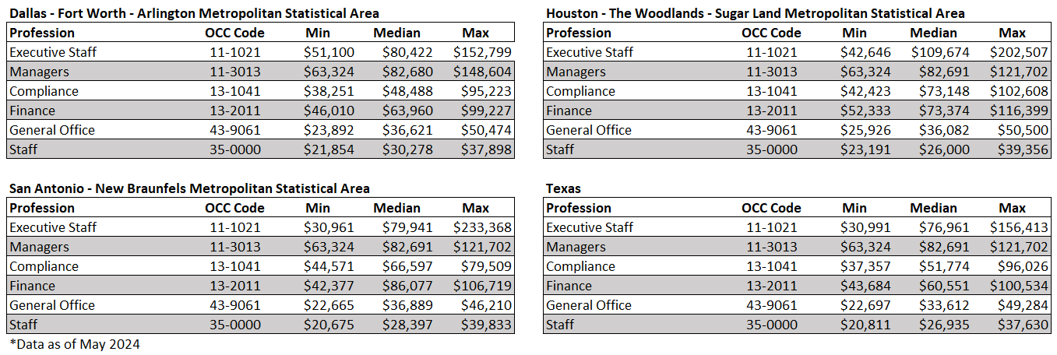

(Texas Workforce Commission, Wages by Profession, 2023)
(Bureau of Labor Statistics: What Are Percentile Wages?)

TABLE 2 – Metropolitan Statistical Areas – Counties

Dallas-Fort Worth-Arlington MSA | Houston-The Woodlands-Sugar Land MSA | San Antonio-New Braunfels MSA
- Collin County  - Dallas County  - Denton County  - Ellis County  - Hood County  - Hunt County  - Johnson County  - Kaufman County  - Parker County  - Rockwall County  - Somervell County  - Tarrant County  - Wise County | - Austin County  - Brazoria County  - Chambers County  - Fort Bend County  - Galveston County  - Harris County  - Liberty County  - Montgomery County  - Waller County | - Atascosa County  - Bandera County  - Bexar County  - Comal County  - Guadalupe County  - Kendall County  - Medina County  - Wilson County

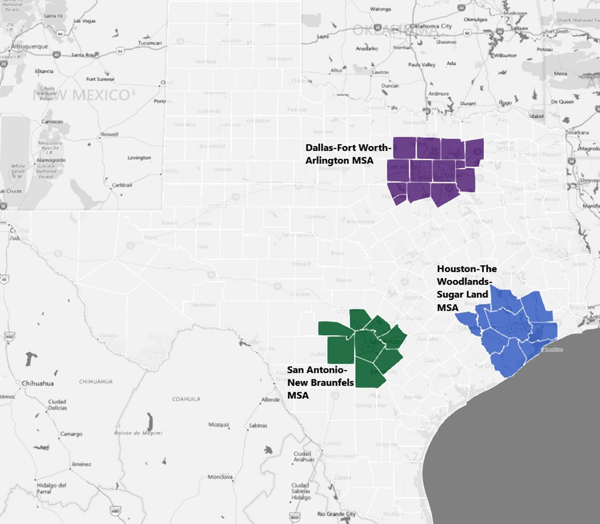

(Bureau of Labor Statistics: May 2023 Metropolitan and Nonmetropolitan Area Definitions)

For a more detailed explanation of this guideline please see the Additional Resources in the appendix.

CONCLUSION

Allowability of cost is a concept to which all publicly funded programs must adhere. Factors included in the concept of allowability pertain to whether the cost is reasonable and allocable.

To ensure that agencies that administer public funds are being good stewards of federal awards, The Federal Code of Regulations states, “Compensation for employees engaged in work on Federal awards will be considered reasonable to the extent that it is consistent with that paid for similar work in other activities of the non-Federal entity. In cases where the kinds of employees required for Federal awards are not found in the other activities of the non-Federal entity, compensation will be considered reasonable to the extent that it is comparable to that paid for similar work in the labor market in which the non-Federal entity competes for the kind of employees involved.” (eCFR: OMB 2 CFR 200.430)

As it relates to CACFP, FNS Instruction 796-2 Rev. 4 states, “All participating institutions must operate a nonprofit food service principally for the benefit of enrolled participants and maintain records documenting the operation of that food service. Nonprofit food service includes all food service operations conducted by the institution principally for the benefit of enrolled participants, from which all of the Program reimbursement funds are used solely for the operation or improvement of that food service… Salaries or hourly rates for operating or administrative labor are reasonable when the rates that are charged are consistent with rates paid for similar work in the same area in which the institution is located or consistent with the amounts reported by the U.S. Department of Labor or State labor department for compensation for that field of employment in the same or a comparable geographic location. (FNS 796-2 Rev, 4, pp. 5, 48)

The intent of this paper is to clarify the Texas Department of Agriculture, Food and Nutrition Division’s position on CACFP nonprofit food service program’s salary and wage income as it relates to the concept of allowability.

APPENDIX

Excerpts from the NAICS

The North American Industry Classification System (NAICS) is unique among industry classifications in that it is constructed within a single conceptual framework. Economic units that have similar production processes are classified in the same industry, and the lines drawn between industries demarcate, to the extent practicable, differences in production processes. This supply-based, or production-oriented, economic concept was adopted for NAICS because an industry classification system is a framework for collecting and publishing information on both inputs and outputs, for statistical uses that require that inputs and outputs be used together and be classified consistently. Examples of such uses include measuring productivity, unit labor costs, and the capital intensity of production, estimating employment-output relationships, constructing input-output tables, and other uses that imply the analysis of production relationships in the economy. The classification concept for NAICS leads to production of data that facilitate such analyses (p. 3).

624 - Social Assistance

Industries in the Social Assistance subsector provide a wide variety of social assistance services directly to their clients. These services do not include residential or accommodation services, except on a short-stay basis.
- 624100 Individual and Family Services
  - 624110 Child and Youth Services
  - 624120 Services for the Elderly and Persons with Disabilities
  - 624190 Other Individual and Family Services
- 624200 Community Food and Housing, and Emergency and Other Relief Services
  - 624210 Community Food Services
  - 624221 Temporary Shelters
  - 624229 Other Community Housing Services
  - 624230 Emergency and Other Relief Services
- 624300/624310 Vocational Rehabilitation Services
- 624400/624410 Child Care Services

(Census Bureau: NAICS Social Assistance 2022)

Frequently Asked Questions about Economic Classifications

- What is the purpose of an industry classification system?

An industry classification system facilitates the collection, tabulation, presentation, and analysis of data relating to establishments and ensures that data about the U.S. economy published by U.S. statistical agencies are uniform and comparable. NAICS ensures that such data are uniform and comparable among Canada, Mexico, and the United States.

- What is an establishment?

An establishment is generally a single, physical location at which economic activity occurs (e.g., store, factory, farm, etc.). An enterprise consists of one or more locations that are more than 50 percent owned by the same entity performing the same or different types of economic activities. Each establishment of that enterprise is assigned a NAICS code, based on its own primary activity.

- How can I determine the correct NAICS code for my business?

To determine the correct NAICS code for your business:

  - You can use the search feature at https://www.census.gov/naics/. In the "2022 NAICS Search" box on the left side of that page, enter a keyword that describes your kind of business. A list of primary business activities containing that keyword and the corresponding NAICS codes will appear. Choose the one that most closely corresponds to your primary business activity or refine your search to obtain other choices.

  - Rather than searching through a list of primary business activities, you may also view the complete 2022 NAICS structure with codes and titles by clicking on "2022 NAICS" on the left-hand column from the NAICS main Web page. Then click on the 2-digit Sector code to see all the NAICS codes under that Sector. Then choose the 6-digit code of your interest to see the corresponding definition, as well as cross-references and index items, when available.

(Census Bureau, NAICS 2022)

Occupational Employment and Wage Statistics (OEWS) Overview

The Occupational Employment and Wage Statistics (OEWS) program conducts a semiannual survey designed to produce estimates of employment and wages for specific occupations. The OEWS program collects data on wage and salary workers in nonfarm establishments in order to produce employment and wage estimates for about 800 occupations. Data from self-employed persons are not collected and are not included in the estimates. The OEWS program produces these occupational estimates for the nation as a whole, by state, by metropolitan or nonmetropolitan area, and by industry or ownership. The Bureau of Labor Statistics produces occupational employment and wage estimates for approximately 415 industry classifications at the national level. The industry classifications correspond to the sector, 3-, 4-, and selected 5- and 6-digit North American Industry Classification System (NAICS) industrial groups.
The OEWS survey covers all full-time and part-time wage and salary workers in non-farm industries. Surveys collect data for the payroll period including the 12th day of May or November. The survey does not cover the self-employed, owners and partners in unincorporated firms, household workers, or unpaid family workers.
Wages for the OEWS survey are straight-time, gross pay, exclusive of premium pay.

Uses of OEWS data
- Analysis of occupational employment
- Analysis of occupational wages
- Development of occupational projections
- Vocational counseling and planning
- Industry skill and technology studies
- Market analysis

(Bureau of Labor Statistics: Occupational Employment Statistics: Overview, 2024)
(Bureau of Labor Statistics: Technical Notes for May 2023 OEWS Estimates, 2024)

Categorical Roles (as defined by the BLS, Standard Occupation Classification)

- Executive Staff
- 11-1021 General and Operations Managers
Plan, direct, or coordinate the operations of public or private sector organizations, overseeing multiple departments or locations. Duties and responsibilities include formulating policies, managing daily operations, and planning the use of materials and human resources, but are too diverse and general in nature to be classified in any one functional area of management or administration, such as personnel, purchasing, or administrative services. Usually manage through subordinate supervisors. Excludes First-Line Supervisors.
- Managers
  - 11-3013 Managers
Plan, direct, or coordinate one or more administrative services of an organization, such as records and information management, mail distribution, and other office support services, or coordinate operations and functionalities of facilities and buildings. May include surrounding grounds or multiple facilities of an organization's campus. (Note: This definition combines information from both 11-3012 Administrative Services Managers and 11-3013 Facilities Managers.)
- Compliance
  - 13-1041 Compliance Officers
Examine, evaluate, and investigate eligibility for or conformity with laws and regulations governing contract compliance of licenses and permits, and perform other compliance and enforcement inspection and analysis activities not classified elsewhere. Typically reports to a supervisor or manager.
- Finance
  - 13-2011 Financial Specialists
Examine, analyze, and interpret accounting records to prepare financial statements, give advice, or audit and evaluate statements prepared by others. Install or advise on systems of recording costs or other financial and budgetary data. Typically reports to head of unit/department.
- General Office
  - 43-9061 Office Clerks, General
General perform duties too varied and diverse to be classified in any specific office clerical occupation, requiring knowledge of office systems and procedures. Clerical duties may be assigned in accordance with the office procedures of individual establishments and may include a combination of answering telephones, bookkeeping, typing or word processing, office machine operation, and filing. Typically reports to a supervisor or manager.
- Staff, Operations
  - 35-0000 Food Preparation and Service Related Occupations
Food Preparation and Serving Related Workers

(Bureau of Labor Statistics, 2018 Standard Occupational Classification System)

Excerpt from CFR 200

§200.430 Compensation—personal services

(a) General. Compensation for personal services includes all remuneration, paid currently or accrued, for services of employees rendered during the period of performance under the Federal award, including but not necessarily limited to wages and salaries. Compensation for personal services may also include fringe benefits which are addressed in §200.431 Compensation—fringe benefits. Costs of compensation are allowable to the extent that they satisfy the specific requirements of this part, and that the total compensation for individual employees:
(1) Is reasonable for the services rendered and conforms to the established written policy of the non-Federal entity consistently applied to both Federal and non-Federal activities;
(2) Follows an appointment made in accordance with a non-Federal entity's laws and/or rules or written policies and meets the requirements of Federal statute, where applicable; and
(3) Is determined and supported as provided in paragraph (i) of this section, Standards for Documentation of Personnel Expenses, when applicable.
(b) Reasonableness. Compensation for employees engaged in work on Federal awards will be considered reasonable to the extent that it is consistent with that paid for similar work in other activities of the non-Federal entity. In cases where the kinds of employees required for Federal awards are not found in the other activities of the non-Federal entity, compensation will be considered reasonable to the extent that it is comparable to that paid for similar work in the labor market in which the non-Federal entity competes for the kind of employees involved.

(eCFR: OMB 2 CFR 200.430)

Excerpts from FNS 796-2 Rev. 4

VII A 3 - Allowability. Costs must meet the following factors:
- Necessary. The cost must represent an activity or function that is generally recognized as reasonable and necessary for the operation of the Program. The cost must be essential to fulfill regulatory requirements for proper and efficient administration of the Program.

To determine if a cost is necessary, the State agency must consider if it is needed for the operation of the Program. Is this cost item needed to fulfill proper administration of the Program?

Some costs are allowable but the entire amount of the cost item may not be reasonable to fulfill proper and efficient administration of the Program. Costs such as reasonable and necessary salary amounts, salary increases, salary benefits such as gym memberships, and computer equipment are allowable costs.

The State agency should establish policy that is consistent with the cost and Program regulations regarding what cost items require additional information to approve the cost. For example, salary raise thresholds, salary levels over Bureau of Labor Statistics, vehicles, etc.

- Reasonable. The type and amount of cost must not exceed what a prudent person would pay under the same circumstances. Factors that are used to determine reasonableness include:
- The restraints imposed by generally accepted sound business practices;
- Arms-length bargaining;
- Federal and State laws and regulations;
- Whether the individuals acted with prudence considering their responsibilities to the organization, its members, employees, and clients, the public at large, the Federal Government and the CACFP; and
- Whether there are significant deviations from established practices which may unjustifiably increase costs.
- Authorized. The cost must be authorized or at least not prohibited under Federal, State or local laws, regulations and this Instruction.
- Limitations. The cost must conform to any limitations or exclusions set forth in this Instruction, Federal, State or local laws or regulations as to types or amounts of cost items.
- Current. The cost must not be assignable or included as a cost to a prior or future period.
- Multiple Awards. The cost must not be assignable or included as a cost to any other current or prior Federally-financed Program.
- Consistent treatment. The cost must be treated consistently through the application of U.S. GAAP.
- Net cost. The cost must be net of all applicable credits.
- Allocated. The cost must be properly allocated so that only the allowable share of the cost is assigned to the Program.
- Documented. Costs must be supported by documentation that adequately demonstrates that the costs:
(1) Have been incurred;
(2) Are Program costs; and
(3) Comply with all applicable laws, regulations and this Instruction.

VIII I 23d. Special Considerations in Determining Allowability.
When special considerations exist, allowable costs are limited to the amount of compensation approved for the actual performance of Program services. The State agency must determine that the compensation costs are necessary and reasonable for the actual services performed by the individual and do not represent an attempt by institutions reimbursed at the lesser of rates or cost to maximize or distribute excess Program earnings.

VIII I 23e. Salaries and Wages
Salaries or hourly rates for operating or administrative labor are reasonable when the rates that are charged are consistent with rates paid for similar work in the same area in which the institution is located or consistent with the amounts reported by the U.S. Department of Labor or State labor department for compensation for that field of employment in the same or a comparable geographic location.

(USDA FNS 796-2 Rev. 4)

Labor Costs Example (FNS 796-2 Rev, 4, n.d., pp. Q&A, p. 6-7)

Q. A sponsoring organization of centers and homes submits its annual budget for approval. Some of the centers are unaffiliated. Some centers purchase, others prepare their meals. Last year the centers’ meal reimbursement was $2,920,150. The day care home administrative budget was $169,200. The salary for the CEO is $200,000 per year. The cost allocation plan indicates the CEO spends a total of 50 percent of her time on Program activities and 50 percent of her time on non-Program activities. Is this a reasonable salary?

A. The level of compensation needs to be reasonable and commensurate with the services provided by the individual and conform to the institution’s written compensation policy. In this example the organization is paying $200,000 in annual salary to the CEO, however, only $62,798 of which is chargeable to the CACFP if she spends 50 percent of her time on Program activities. Here’s why. The Bureau of Labor Statistics indicates the salary for a public administrator is $125,595. In this instance the state agency could approve the $125,595 salary, which would mean $62,798 of the CEO’s salary is permitted as an allowable cost to the Program $62,798 [$125,595/2 = $62,798]. It is an appealable action when the State agency denies approving a budget item.

In the event that the CEO were to receive $200,000 in annual salary, each CACFP section (day care homes & centers) would only be allowed to charge $31,399 for the CEO salary [$125,595/4 = $31,399]. The difference between the State agency approved salary and the actual salary of $200,000 would need to be paid with non-Federal funds.

Therefore, requiring the sponsoring organization to use non-Program funds to pay for the unallowable portion of the CEO’s salary will free up $37,203 in Program funds for centers and homes, [$200,000-$125,595 = $74,405. $74,405/2 = $37,203], or, to view another way, it will free up $18,602 [$37,203/2 = $18,602] in Program funds for each section (day care homes, centers) to pay for other necessary Program costs.

Additional Question and Response

Q. Professionally, I am a teacher, but for CACFP I am a lunchroom monitor. Should my salary be in line with the salary for teachers in my area?

A. No. The level of compensation needs to be reasonable and commensurate with the services provided by the individual to the CACFP food service program. Your role under the CACFP is that of a monitor, therefore you are general staff. Compensation with any child nutrition program is based on the role you perform and not on your professional credentials.

Excerpt from BLS - Metropolitan Area Concepts and Standards

The United States Office of Management and Budget (OMB) delineates metropolitan and micropolitan statistical areas according to published standards that are applied to Census Bureau data. The general concept of a metropolitan or micropolitan statistical area is that of a core area containing a substantial population nucleus, together with adjacent communities having a high degree of economic and social integration with that core. Currently delineated metropolitan and micropolitan statistical areas are based on application of 2020 standards (which appeared in the Federal Register on July 16, 2021) to 2020 Census and 2016-2020 American Community Survey data, as well as Vintage 2021 Population Estimates Program data. Current metropolitan and micropolitan statistical area delineations were announced by OMB effective July 2023.

Standard delineations of metropolitan areas were first issued in 1949 by the then Bureau of the Budget (predecessor of OMB), under the designation "standard metropolitan area" (SMA). The term was changed to "standard metropolitan statistical area" (SMSA) in 1959, and to "metropolitan statistical area" (MSA) in 1983. The term "metropolitan area" (MA) was adopted in 1990 and referred collectively to metropolitan statistical areas (MSAs), consolidated metropolitan statistical areas (CMSAs), and primary metropolitan statistical areas (PMSAs). The term "core based statistical area" (CBSA) became effective in 2000 and refers collectively to metropolitan and micropolitan statistical areas.

OMB has been responsible for the official metropolitan areas since they were first delineated, except for the period 1977 to 1981, when they were the responsibility of the Office of Federal Statistical Policy and Standards, Department of Commerce. The standards for delineating metropolitan areas were modified in 1958, 1971, 1975, 1980, 1990, 2000, 2010, and 2021.

Defining Metropolitan and Micropolitan Statistical Areas - The 2020 standards provide that each CBSA must contain at least one urban area of 10,000 or more population. Each metropolitan statistical area must have at least one urban area of 50,000 or more inhabitants. Each micropolitan statistical area must have at least one urban area of at least 10,000 but less than 50,000 population.

Under the standards, the county (or counties) in which at least 50 percent of the population resides within urban areas of 10,000 or more population, or that contain at least 5,000 people residing within a single urban area of 10,000 or more population, is identified as a "central county" (counties). Additional "outlying counties" are included in the CBSA if they meet specified requirements of commuting to or from the central counties. Counties or equivalent entities form the geographic "building blocks" for metropolitan and micropolitan statistical areas throughout the United States and Puerto Rico.

If specified criteria are met, a metropolitan statistical area containing a single core with a population of 2.5 million or more may be subdivided to form smaller groupings of counties referred to as "metropolitan divisions."

As of July 2023, there are 387 metropolitan statistical areas and 538 micropolitan statistical areas in the United States.

(Bureau of Labor Statistics: Metropolitan & Micropolitan Statistical Areas, 2023)

CACFP Salary Determination

According to the Bureau of Labor Statistics, “Occupational wages vary by industry and employer. Diverse working conditions, clientele, and training requirements are among the reasons why wages might differ from one employment setting to the next… Some states or areas have higher wages than others for jobs in an occupation. Local demand for the work and cost of living are among the geographic factors affecting wages.” (Torpey, 2015).
As such, the following factors are also taken into consideration when establishing reasonableness and allocability:
- Credentials
- Experience
- Industry
- Task (Field of employment)
- Geographic location
- Size of organization by program reimbursement
Further, Center and Center sponsor salaries must be within certain mandated limits (i.e. < 15% administrative cost).
Methodology:
- Industry, Task
To determine reasonableness, F&N uses industry type as set by The North American Industry Classification System (NAICS). The industry type is established as subsector 624 – social assistance (see Social Assistance for more information).
Field of employment is matched to meet the roles consistent with that appropriate for a nonprofit food service program and categorized to fill that role. Texas institutions operating the CACFP program may use many different titles for the same responsibilities. For example, the person running an institution may be titled as a CEO, President, Chief Executive, Food Service Manager, Operations Manager, Center Manager. However, only the role the individual satisfies as it pertains to the nonprofit food service program will be considered. Program salary is therefore approved only for those duties applicable toward the fulfilment of the nonprofit food service. As a result, to ensure that roles meet certain criteria, five administrative and one operational categorically significant function have been established.
- Executive staff
- Managers
- Compliance
- Finance (excluding Finance managers)
- General Office (excluding office managers)
- Staff, Operations

These functional areas are in line with those needed to run a nonprofit food program (see Categorical Roles for general definitions of categories) and are defined using occupation groups provided by the Bureau of Labor Statistics.
- Credentials, Experience, Size
The BLS reports national median salaries (50th percentile) for Occupational Employment and Wage Statistics (OEWS) groups based on standardized position category. The OEWS program collects data on wage and salary workers in non-farm establishments to produce employment and wage estimates for about 800 occupations.
(Occupational Employment Statistics: Overview, 2024)
Example
National Median Data – NAICS 624000 as of May 2019 (OEWS Data)
Full Name | Annual Median Wage | Category
Program Management
Operations Specialties Managers | $ 75,870 | Executive staff
Other management Occupations | $ 69,960 | Managers
Non-Management
Financial Specialist | $ 58,800 | Finance
Compliance Officers | $ 48,820 | Compliance
Office and Administrative Support Occupations | $ 30,960 | General Office
Food Preparation and Service Related Occupations | $ 25,270 | Staff, Ops

Percentile | 10%  (min) | Median Wage | 90%  (max)
Annual Wage | $41,194 | $60,009 | $116,600
Many factors can go into why individuals who fulfill the same role can have differences in salary. Factors such as credentials, experience, and size of organization can all affect an individual’s compensation. To account for this disparity, the six position categories apply a Minimum – Maximum based on the OEWS percentile wages.
(Bureau of Labor Statistics: What are Percentile Wages, 2011)
- Geographic location
Another factor in salary ranges is location. Salaries may differ based on factors such as industry saturation, competition, and cost of living. Because of these differences, the salaries taken from the BLS are defined based on the metropolitan statistical area (MSA). The Texas Workforce Commission pulls these salaries from the BLS and we have compiled these median salaries by categorical roles listed in the appendix. To account for salary and wage differences across the state, TDA uses three distinct MSAs with the remainder of the state based on the overall Texas salary and wage data. All salaries are based on the last available year on the TWC website.
(Texas Workforce Commission: Wage by Profession, 2023)

TABLE 3 - Employer Cost for Employee Compensation

Compensation Component | Private Industry
Wages and Salaries | 70.7%
Benefits | 29.3%

(Bureau of Labor Statistics: Compensation split for private industry workers, December 2023)

CACFP Salary and Wage Tables

In TDA’s efforts to be good stewards of the financial and property resources entrusted to us for the administration of the federal food and nutrition programs, TDA has employed the following ranges for salary and wage income. Key to ensuring that all of Texas’ children have access to safe, nutritious, and balanced meals, we must all endeavor to be responsible in our cost allocation as it pertains to our programs.

(Texas Workforce Commission: Occupational Employment Statistics, 2023)

ADDITIONAL RESOURCES
Dictionary.com. Career. (n.d.). http://www.dictionary.com/browse/career. Accessed June 12, 2024.
Texas Department of Agriculture, Food & Nutrition. Program Statistics. n.d. https://squaremeals.org/FandNResources/ProgramStatistics.aspx. Accessed June 12, 2024.
Texas Department of Agriculture. 2023-2024 CACFP Reimbursement Rates. n.d. http://www.squaremeals.org/Programs/ChildandAdultCareFoodProgram/CACFPReimbursementRates.aspx. Accessed June 12, 2024.
Texas Workforce Commission. Texas Labor Market Information Occupational Employment Statistics. 2023. https://texaslmi.com/LMIbyCategory/Wages. Accessed May 7, 2024.
Torpey, E. Same occupation, different pay: How wages vary: Career Outlook. U.S. Bureau of Labor Statistics. May, 2015. https://www.bls.gov/careeroutlook/2015/article/wage-differences.htm. Accessed June 12, 2024.
U.S. Bureau of Labor Statistics. Economic News Release, Table 4. Private industry workers by occupation and industry group. March 13, 2023. https://www.bls.gov/news.release/ecec.t04.htm. Accessed June 13, 2024.
U.S. Bureau of Labor Statistics. Employer Costs for Employee Compensation Summary. March 13, 2024. https://www.bls.gov/news.release/ecec.nr0.htm. Accessed June 12, 2024.
U.S. Bureau of Labor Statistics. Occupational Employment and Wage Statistics: May 2023 Metropolitan and Nonmetropolitan Area Definitions. April 3, 2024. https://www.bls.gov/oes/current/msa_def.htm#T. Accessed June 14, 2024.
U.S. Bureau of Labor Statistics. Occupational Employment and Wage Statistics: Overview. April 3, 2024. https://www.bls.gov/oes/oes_emp.htm#scope. Accessed June 12, 2024.
U.S. Bureau of Labor Statistics. Occupational Employment and Wage Statistics: Research Estimates by State and Industry. May 2023. https://www.bls.gov/oes/current/oes_research_estimates.htm. Accessed April 2024.
U.S. Bureau of Labor Statistics. Occupational Employment and Wage Statistics, Tables Created by BLS. May 2023. https://www.bls.gov/oes/tables.htm. Accessed May 7, 2024.
U.S. Bureau of Labor Statistics. Occupational Employment and Wage Statistics, Technical Notes for May 2023 OEWS Estimates. April 3, 2024. https://www.bls.gov/oes/current/oes_tec.htm. Accessed June 14, 2024.
U.S. Bureau of Labor Statistics. Standard Occupational Classification: 2018 SOC Major Groups. 2018. https://www.bls.gov/soc/2018/home.htm. Accessed June 12, 2024.
U.S. Bureau of Labor Statistics. What are Percentile Wages. July 8, 2011. https://www.bls.gov/oes/oes_perc.htm. Accessed June 12, 2024.
U.S. Census Bureau. Metropolitan and Micropolitan Statistical Areas, About. July 25, 2023. https://www.census.gov/programs-surveys/metro-micro/about.html. Accessed June 12, 2024.
U.S. Census Bureau. North American Industry Classification System. 2022. https://www.census.gov/naics/. Accesssed June 12, 2024.
U.S. Department of Agriculture, Food and Nutrition Service. FNS 796-2 Rev, 4. n.d. https://www.fns.usda.gov/sites/default/files/796-2%20Rev%204.pdf. Accessed June 12, 2024.
U.S. Office of Management and Budget. 2 CFR 200.430. November 12, 2020. eCFR. https://www.ecfr.gov/on/2020-11-12/title-2/part-200/section-200.430. Accessed June 12, 2024.
Wright, J. & Rotz, J. H. Resonable Compensation. U.S. Internal Revenue Service, 1993. https://www.irs.gov/pub/irs-tege/eotopici93.pdf. Accessed June 12, 2024.

